CARPET WASHER
Instruction Manual

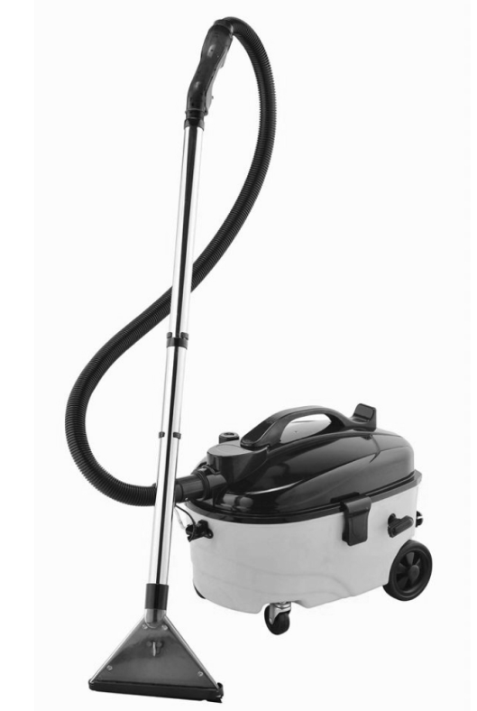


IMPORTANT SAFETY INSTRUCTIONS
READ CAREFULLY AND KEEP FOR FUTURE REFERENCE
Carefully read this manual before using this appliance.
Ensure that you know how the appliance functions and how to operate it.
Maintain the appliance in accordance with the instructions to ensure that it functions properly.
Keep this manual with the appliance. If the appliance is to be used by a third party, this instruction manual must be supplied with it.
The safety instructions do not by themselves eliminate any danger completely and proper accident prevention measures must always be used.
No liability can be accepted for any damage caused by non-compliance with these instructions or any other improper use or mishandling.
Do not use this appliance if it has been dropped or damaged in any way, or if the supply cord is damaged.

PACKAGE CONTENTS

1 x Carpet Washer 2 x Extension Tube 1 x Hose
1 x Cleaning Head 1 x Instruction Manual

Confirm all parts before disposing of carton. Safely dispose of all plastic bags and other packaging components. They may be potentially dangerous to children.

TECHNICAL SPECIFICATION

Model ZN1101 220-240V ~ 50 Hz 1400 Watt

Due to ongoing product improvements, specifications and accessories may change without notice. Actual product may differ slightly to that depicted.


GENERAL AND ELECTRICAL SAFETY
Do not use this appliance for any use other than its intended purpose
When using electric appliances always observe safety regulations where applicable to reduce the risk of fire, electric shock and personal injury. Always check that the power supply corresponds to the voltage on the rating plate. Always unplug the appliance when not in use.

Supply Cord and Plug
Always unplug from mains supply when not in use. Do not abuse or damage the power cord. If the supply cord is damaged, it must be replaced by the manufacturer or its service agent or a similarly qualified person in order to avoid a hazard. Do not let the supply cord touch hot surfaces.

Children and Infirm Persons
This appliance is not intended for use by persons (including children) with reduced physical,sensory or mental capabilities, or lack of experience and knowledge, unless they have been given supervision or instruction concerning use of the appliance by a person responsible for their safety. Children must be supervised to ensure they do not play with the appliance.

Water
Do not immerse appliance or supply cord in water. Do not handle with wet hands or use in damp situations. Only use the appliance on wet surfaces when cleaning them. Do not use to pick up any liquid other than cleaning solution dispensed from this machine. Do not expose to rain. Do not use appliance to dispose of wet or damp materials such as mud, tile grout, plaster filler, or caulking.

Double Insulation Safety
This appliance is double insulated for your protection. Do not attempt to repair a double insulated appliance.

Use and Environment
Do not use outdoors. Do not use this appliance for anything other than its intended use. Use only manufacturer’s recommended attachments. Do not use without tank in place. Do not use with any opening or outlet blocked. Keep free of dust, lint, hair and anything that may reduce airflow.
Keep hair, loose clothing, fingers and all parts of the body away from openings and moving parts.
Do not use to pick up flammable or toxic liquids, such as gasoline, chlorine bleach or drain cleaner, or use in areas where they may be present.
Do not pick up anything that is burning or smoking, such as cigarettes, matches, or hot ashes.
Damaged or Dropped
Always inspect your appliance before use. Check parts are correctly attached. Do not use this appliance if it has been damaged, dropped, left outdoors or dropped in water. Return it to an authorised service dealer for examination and repair.

DIAGRAM
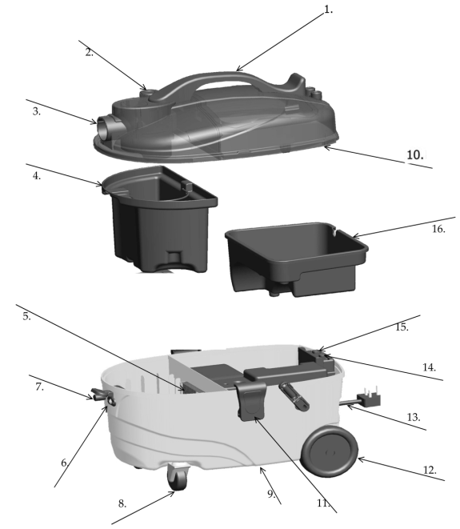
1. Handle 2. Defoamer 3. Hose Connector 4. Waste Water Tank
5. Motor Filter 6. Transparent connector 7. Activator 8. Front Wheel
9. Body Tank 10.Body Cover 11.Clip 12.Rear Wheel 13.Power Cord
14.Switch for pump 15.Switch for motor 16.Clean Water Tank
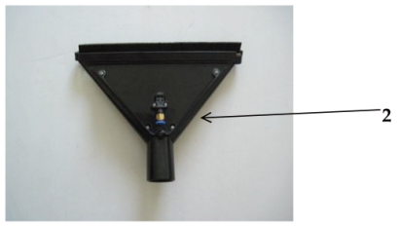
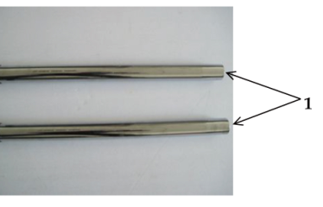

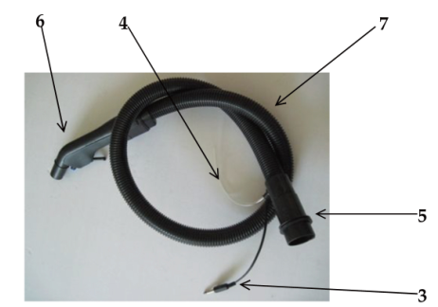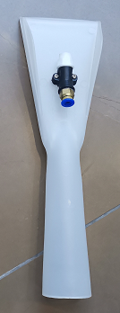
1. Extension Tube 2. Cleaning Head 3. Pin 4. Water Tube
5. Connector 6. Bend Connector 7. Hose 8.Sofa washing brush

ASSEMBLY
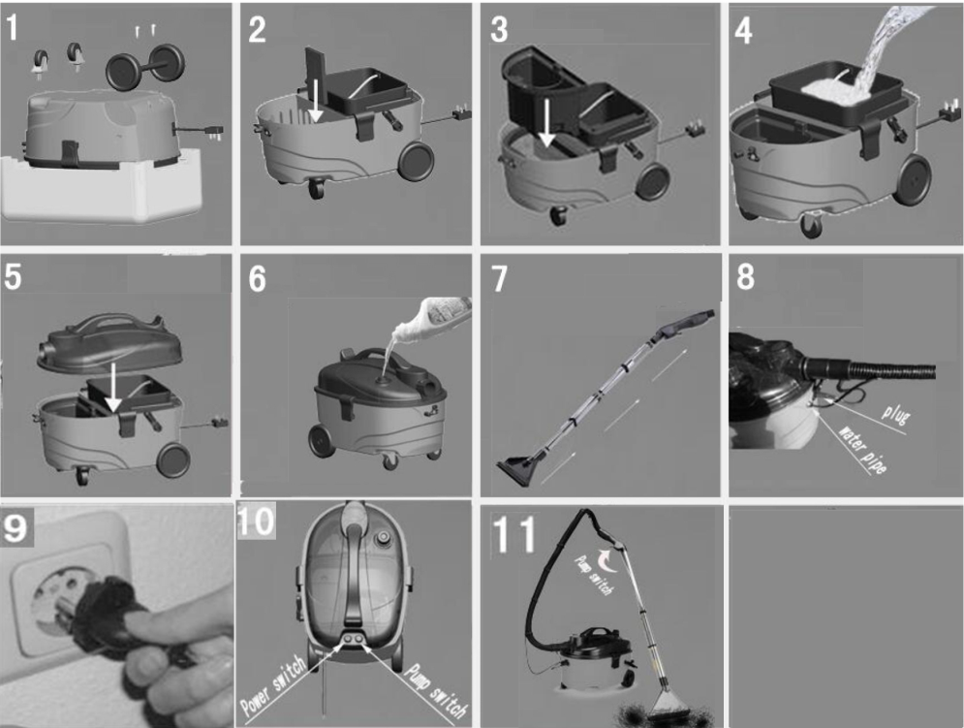
1, Get out two front wheels from the body, and inserting them into the bottom. Then taking out two
rear wheels, using the screws to assemble on the connector.(fig.1)
2, Check the sponge filter, if without the sponge filter, to fix it again.(fig.2)
3, Place the dust collector into the body.(fig.3)
4, Before using, to fill clean water into the tank.(fig.4)
5, Place the vacuum body to the container.(fig.5)
6, Pour the cleaning agent.(fig.6)
7, Take our the connecting tube and hose, then connect one by on.(fig.7)
8, Connect the hose in the air inlet, attach the cable for activator to the socket protected by the cover,and place the transparent hose into transparent connector.(fig.8)
9, Place the plug into the suitable power.(fig.9)
10, Turn on the motor and pump switch, the vacuum cleaner begin to work.(fig.10)
11, Clean the carpet, turn on the handle switch, the pump begin to spray, if press Off the switch of the handle switch, the spraying will be interrupted.(fig.11)
12, Turn off the power after cleaning, and ringing the cable, then empty the container, and clean the dust collector, sponge filter,place them after cleaning one by one.(fig.12)

OPERATION
Use This Appliance is suitable for use on the following surfaces;
Ceramic Tile Glass Windows
Wooden Floors Glass Walls
Ceramic Wall Glass Doors
Carpet
Before use on timber floors or if in any doubt of suitability for use on flooring please check the user care instructions from your flooring manufacturer or consult a flooring specialist with regards to product suitability with individual flooring.
Ensure the Sheffield Carpet Washer is thoroughly tested in a small (30cm 2) inconspicuous area prior to using on a large floor area.
Operating Instructions
Uncoil the supply cable completely. Make sure the Power Switches are in the closed position and connect the supply cord plug into a suitable 220-240V ~ 50Hz socket.
Switches:
Press the “Power” switch, the vacuum motor starts and the cleaner will begin to suck dust and water.
Press the “Pump” switch, the pump will start and you can push the water spray button on the handle to sprinkle water and cleaning solution on the carpet. These two switches can be used independently.
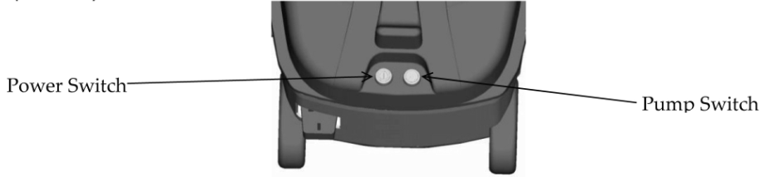
Water Tank:
Pour the appropriate amount of clean water into the clean water tank. Add the cleanser or washing solution if required (Refer to your detergent for correct dilution ratio) and mix thoroughly. You may also remove the clean water tank, add some clean water and cleanser and mix them and then replace.
NOTE: Using warm water will increase the cleaning effect of the water and cleaning solution.(max 50 o C)
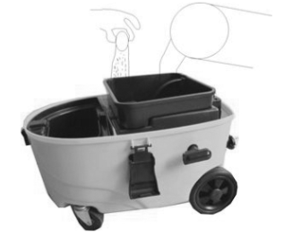
NOTE: Do not fill water and solution above the MAX fill line ion the water tank.

Cleaning the Carpet:
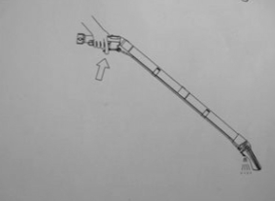
Turn on the power switch and the pump switch; press the water spray button on the handle to sprinkle water onto the carpet. Move the Cleaning Head back and forth to massage and scrub the floor if necessary. Repeat this procedure if flooring requires.

Defoamer:
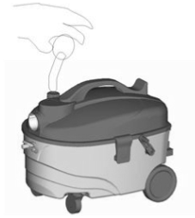
If you have added some washing solution or cleaner in the clean water tank, depending on whether you have used a low foaming solution or not you may need to use defoaming solution to stop a large amount of foam building. You can add the appropriate amount of defoamer in the location shown in the figure below.

Waste Water:
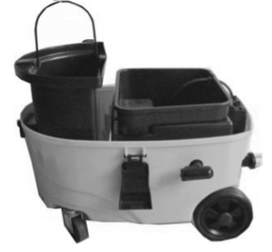
After you have finished cleaning or if you want to stop using the cleaner, please remove the clean water tank and the waste water tank and clean them thoroughly to prevent odours that may be generated by long term holding of water in the tanks.

Power Cord:
The effective length of power cord is 4 meters. Turn the power off and disconnect the plug from the socket when you have finished using the Carpet Washer. Rewind the power cord with the crank until it is fully coiled.
CLEANING METHODS
Normal Soiling:
· Spray water and detergent solution and vacuum up the water in one movement (both power and pump switches on) across the carpet.
· Note: Repeated vacuuming without spraying will shorten the drying time
Heavy Soiling or Stains
· Spray water and detergent solution (Pump switch only) and leave to soak for 10-15 minutes.
· Clean the carpet as per the above Normal Soiling method
Cleaning Tips
· Highly soiled spots should be pre-soaked following the Heavy soiling directions.
· Always work from the cleaned to the uncleaned sections of the Carpet.
· Sensitive surfaces (Rugs, upholstery) require a lower cleaning solution mix, please consult the manufacturer’s instructions of the item in question.
· Some Rug backing can shrink if too much water is used and can cause colours to bleed,please consult rug care instructions before use.
· Brush high-fiber rugs in the direction of the weave after cleaning.
· Do not walk or replace furniture on cleaned surfaces until the carpet has fully dried to avoid pressure spots or rust stains.
· When cleaning previously shampooed carpets, foam may be generated in the dirty water reservoir, add a defoamer to the dirty water tank if this occurs.
MAINTENANCE
Regular maintenance of your appliance will keep it safe and in proper operational order.
Before Cleaning
When not in use or before cleaning, always disconnect the appliance from the mains supply.
Cleaning
Regularly clean the outside of the appliance with a soft damp cloth and dry it with a dry towel.
Do not immerse in water. Do not use harsh solvents to clean the plastic.
Remove and clean the motor filter after each use. Allow to completely dry before putting back in.
Immediately after use clean the water tank, waste water tank and Stainless tubes and hoses.
Disassemble stainless tubes and allow them and other parts to fully dry before storing the appliance.
Do not use any metal tools, abrasive scouring pads, steel wool or other hard cleaning product to clean the surface.
Store in a Safe Place
When not in use store your appliance and all its accessories and instruction manual in a safe and dry place
CARPET CLEANING SOLUTION
This carpet washer will use any commonly availably low foaming carpet cleaner, shampoo or detergent suitable for use in carpet extraction cleaning machines, Please note the Manufacturer’s instructions and warnings for safe use marked on the bottles of any cleaning solutions that you use
If low foaming carpet solutions are not available other carpet cleaning solutions may be used with the appropriate defoamer used at the same time. Please follow all Manufacturers’ instructions with regards to the use and quantities of the cleaners and defoaming solutions.

